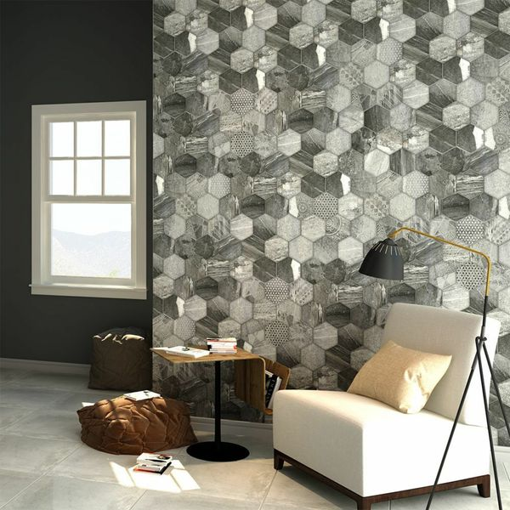

Ruvido Tribal Stone Hexagon Tiles: <https://www.wallsandfloors.co.uk/ruvido-hexagon-tiles-tribal-stone-tiles>

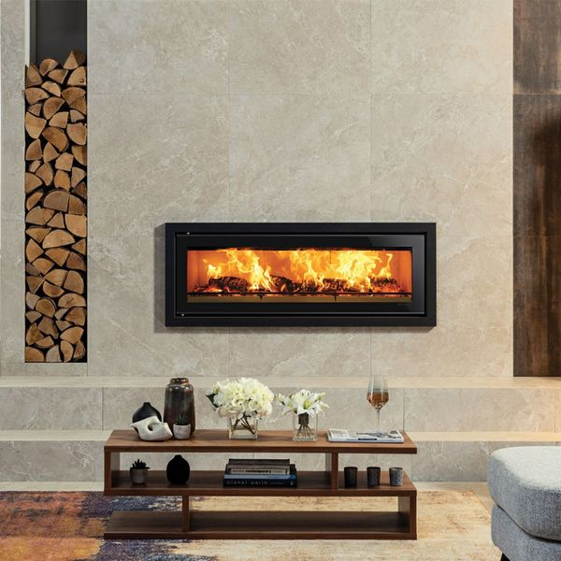

Placid Marble Effect Tiles: <https://www.wallsandfloors.co.uk/placid-marble-effect-tiles>

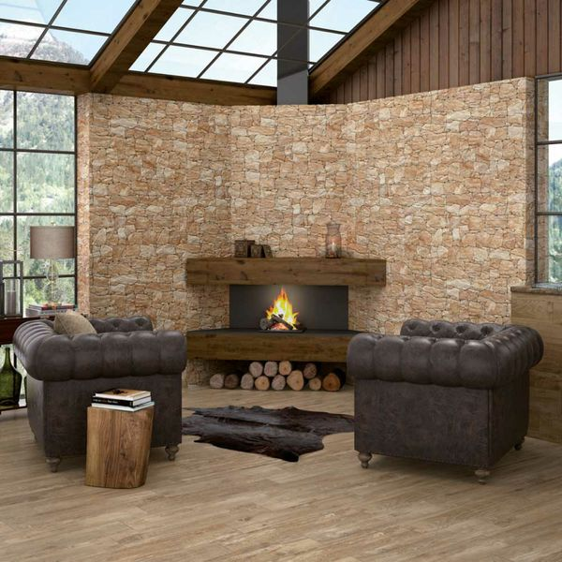

Stacked Sand Stone Effect Tiles: <https://www.wallsandfloors.co.uk/cusco-dry-stone-wall-effect-tiles-stacked-sand-stone-effect-tiles>

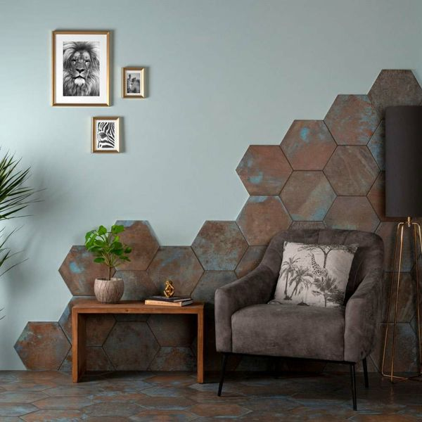

Oaken Teal Oxidised Hexagon Tiles: <https://www.wallsandfloors.co.uk/oaken-teal-tiles>



Mimosa Marble Valley White Gold Tiles: <https://www.wallsandfloors.co.uk/mimosa-marble-valley-white-gold-60x60-tiles>

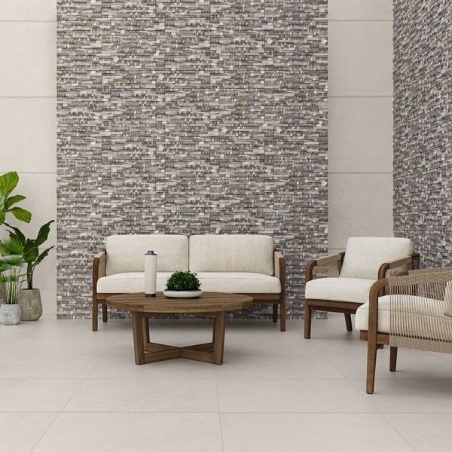

Isidora Pacific Thick Splitface Effect Tiles: <https://www.wallsandfloors.co.uk/isidora-pacific-thick-splitface-effect-tiles>